Go <http://www.hibernate.org/6.html>

download hibernate-3.2.5.ga.zip & hibernate-entitymanager-3.3.1.GA.zip

unzip both

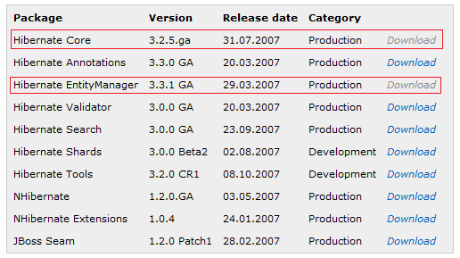

Add following jars to the project

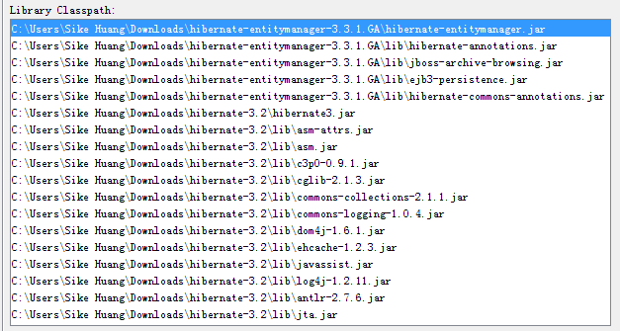

Edit persistence.xml as following

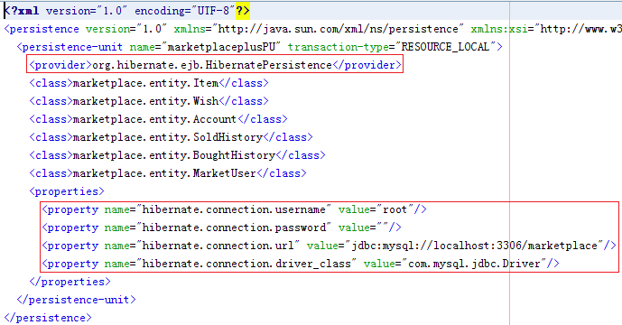

Hibernate-JPA is ready to run!